**Rough Draft (Scroll down to page 3 for the real thing)**

The game starts with a young girl Jervis and the hunter Tommy lives in a forest house in the morning.

They were doing sword and bow training outside the house. (Game tutorial)

(The story will continue when the player(Jervis) talks to the hunter and agrees to go hunt food.)

Cutscene 1

A Merchant had been raided by patrolling goblins. He shouted “Help! Help!”.

When patrolling goblin only 3m away from the merchant.

An arrow hit on that patrolling goblin’s head. Tommy and Jervis appear and come to help the merchant.

Tommy killed most of the goblins. A goblin stays far from jervis and tommy, it holds a bow and shoots an arrow and hurts jervis’ body. Tommy found that goblin and wanted to chase it. However the goblin had already ran away.

This patrolling goblin came back to goblin’s camp and reported what happened to the goblin's commander. The Goblin was angry and roared, it ordered 10 goblin soldiers to chase the target.

Goblins tracked Jervis’ blood stains and caught up with them .

At that moment, The hunter cures jervis in the house and stops her bleeding.

A few seconds later, they heard the roaring outside, they were aware that it’s the goblins.

They went out to fight.

Cutscene 2

The Goblin commander orders goblin soldiers to move forward and fight with jervis and the hunter.

The hunter told jervis to stay back and he went forward to deal with most of the goblins.(Player will control the hunter to have a battle).

However, jervis wasn't aware that one goblin soldier was getting close quietly and sneak attacked jervis suddenly.

Jervis doesn’t have any time to respond to that attack, at that moment, the hunter appeared in front of jervis and got the fatal attack instead of Jervis. The goblin’s sword passes through the hunter's body.

The same past memory appeared in jervis’ memory. It was Jervis’ parents who sacrificed their lives to protect jervis 3 years ago.

Flashback Cutscene 3(a few seconds)

Showed the animation that jervis’ parents protect jervis from the goblin’s attack.

Jervis was shocked at that moment. The hunter said “Don’t stop, run fast and survive as long as you can.” The Hunter used his last strength to hit back goblins. Then he lied under the tree and lost consciousness.

Jervis was sorrowful and angry, she took hunter’s sword, motivated to fight goblins.

She killed all goblins soldiers, then the goblin commander moved forward, the next was the boss battle.

She finally killed the goblin commander. She dug a hole and buried the hunter’s body.

Game End.

**Part 1 (After player click start game)**

Game start at position here (P1)

Time: morning

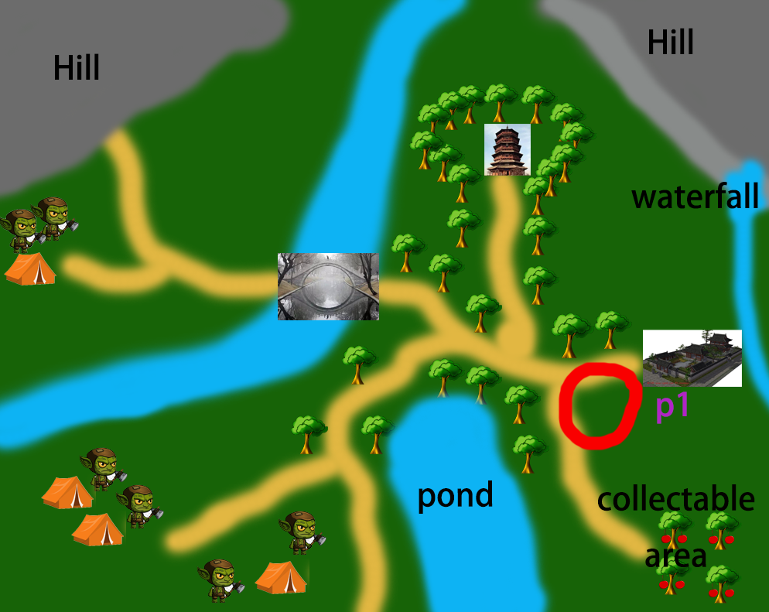

**-Cutscene Start**

**BLACK SCREEN**

**(Outdoor)**

**CUT IN**

**[SFX: Birds Chirping, Trees Swaying in the wind]**

Camera: A shot of the woods, showing part trees, part yellow morning Sky. Serene and peaceful.



**CUT**

**[VFX: Scene slowly transitions from a yellow tint to a bright blue, colors more vibrant, Highlight sunlight rays.]**

**[SFX: Bird flapping it’s wings for take off]**

**[Soundtrack Ref:** [**The Bird At Daybreak**](https://open.spotify.com/track/2ivogqdA5AN8N9Kqq5RqUs?si=DmXChWEhTDKRNW4er65y5g)**]**

Camera: A shot of a small bird on a branch, looking left and right before taking off into the air.

Soundtrack: Comes in the middle of the shot, as the bird is looking around.

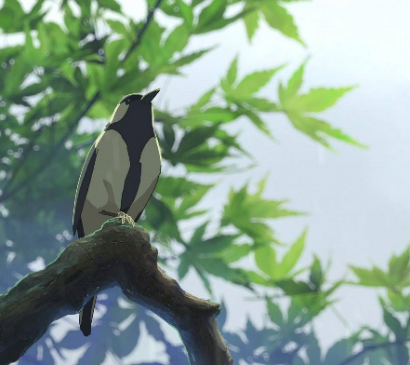

**CUT**

**[SFX: Birds Chirping, Morning forest sounds]**

**Camera:** A low shot of the training dummy outside of Tommy’s house (I couldn’t get a reference image of a low shot, sorry). Trees in the background at a distance. Training dummy looks worn and weathered.

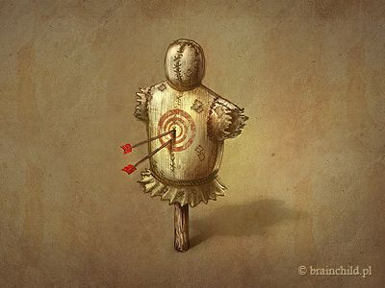

**[SFX: Cloth sounds, Getting dressed]**

**Tommy:** “Are you done yet? What’s taking you so long?”

**[SFX: Dialogue muffled, coming from indoors]**

**Jervis:** “comingg..” (said with a hint of annoyance)

**CUT - Indoors in Jervis’s Room**

**[SFX: cloth sounds tying bandana, nature sounds coming from the outside, muffled]**

**Camera:** Back shot of Jervis tying here bandana, facing the window letting in sunlight.

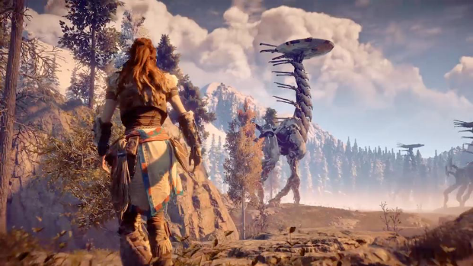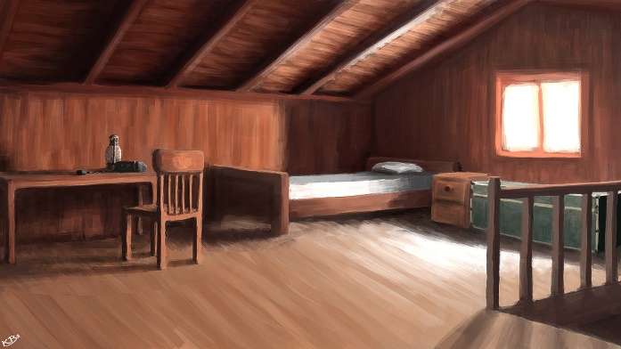

**CUT**

**[SFX: Shoelace sound tying up, Boots on wood clack]**

**Camera:** Close up shot of Jervis tying up the laces on her oversized boots.

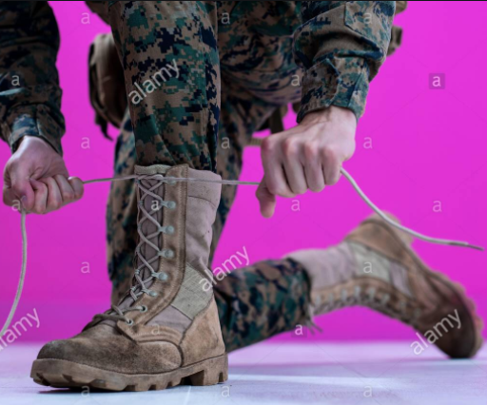

**Soundtrack:** build up, more grand.

**CUT - Outdoors facing the front porch**

**Soundtrack:** End with a grand, powerful and adventurous feel.

**[Soundtrack: Silence/No music]**

**[SFX: Nature sounds dimmed. Give room for dialogue]**

**[SFX: Whetstone Sharpening sword]**

**Camera:** A low shot facing the front porch, showing the hunter on the right sitting down sharpening his sword with a whetstone, and the doorway on the left leading inside the house.

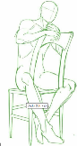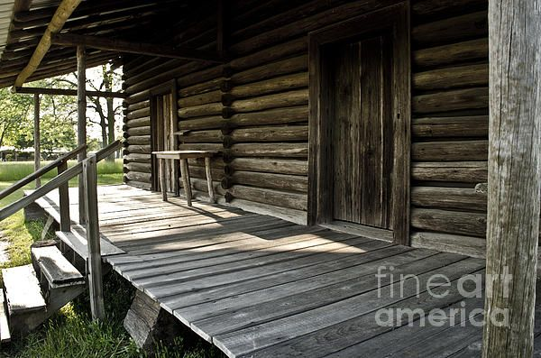

**[SFX: Boots on wood footstep]**

**Jervis:** Stepping out of the house through the doorway and stops in the porch, taking a deep breath while stretching her arms and releasing out her breath in great relief.

**[SFX: Sword sheathing into its case]**

**Tommy:** “Finally.”. Putting away the whetstone and sheathing his sword.

**CUT – Facing the yard**

**Camera:** A shot of the back of Jervis’s head, Show the front yard of the house.

**[SFX: Stretching sounds, cloth]**

**Jervis:** “Ok Old man, what should we do today? Hunt more rabbits? Catch some fish? Or maybee.. get a pet dragon?”. She stretches her hips and arms. Tilting left, left, right, right.

**[SFX: Sounds of Tommy Getting off from his chair and walking]**

**-Cutscene End**

Jervis and Tommy go outside of the house, set the camera to follow them when they are walking.

**Dialogue**-->Tommy: You might not be familiar with combat, let me take you to review it again.

**Tutorial 1**

Sword Combat with dummy enemy (setup combat AI, but do not active attack player.

**KeyPoint:**

* Movement Tutorial (**W, A, S, D, Sprint, Crouch**)
* Learn how to **attack** and **block** attacks from dummy enemies. (**Left/right-click mouse**) and **bow tutorial**?

Notice that **failing to** perfect block will **decrease the stamina bar.**

* Turn off player control, let player get critical attack

pop up a window, prompt the player to press button **numPad 1** to drink the cure item to restore HP.

Give a hint to the player that the item can be crafted from the **tool desk** beside the house.

* Skill tutorial, pop up a window to tell the player that they can use skill by pressing button **Q** and **E**.

**Part 2 (After Game Tutorial)**

Tommy will talk to Jervis(Player) and ask if she is ready for hunting food.

**Option 1**: I’m ready (proceed to story)

Reply(Tommy): Prepare yourself and let’s go.

**Option 2**: I still need to prepare (free play, research the map)

Reply(Tommy): OK. Tell me when you are ready.

**Part 3 Main story episode 1**

**Position: p2**

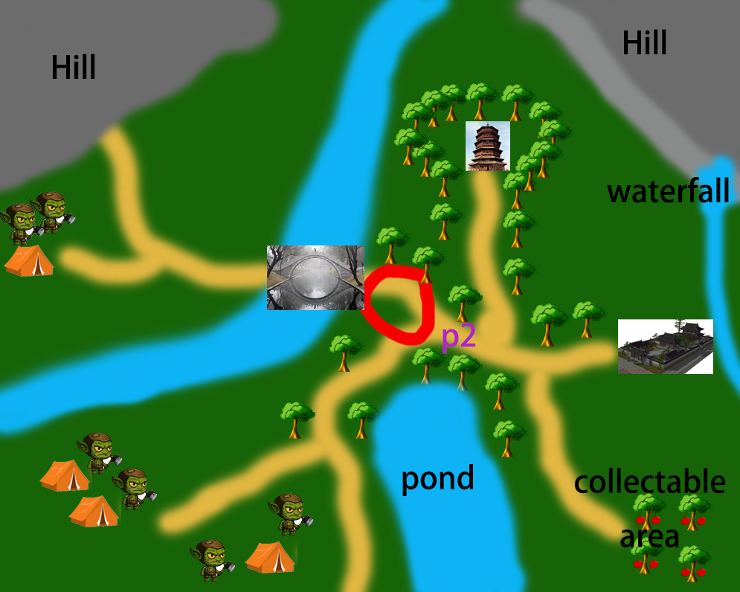

**[SFX: Wooden Cart sound, horse sounds, Grab and Hit sounds, Arrow hit head sound]**

**Cutscene 1**

A Merchant had been raided by patrolling goblins.

**He shouted “Help! Help!”.**

When patrolling goblin only 3m away from the merchant.

**[Soundtrack: Start playing, Heroic feel]**

An arrow hit on that patrolling goblin’s head. Tommy and Jervis appear and come to help the merchant.

**Game Event**:

Set **Camera** to follow with **Tommy**.

There are a few steps from Tommy to merchant.

All goblins turn their faces to Tommy, swing the sword and move forward.

**[Soundtrack: Switch to Battle with the Goblins soundtrack]**

**Game battle start**

**After finished**

**[Soundtrack: Stop Playing]**

**Cutscene 2**

A goblin stays far from jervis and tommy, it holds a bow and shoots an arrow and hurts jervis’ body.

Tommy found that goblin and wanted to chase it. However the goblin had already ran away.

The merchant says thanks to Tommy and leaves.

Tommy carried jervis on his back and got back to the house.

Jervis’ blood dripped on the ground.

Switch to goblin’s camp

That run-away patrolling goblin came back to goblin’s camp and reported what happened to the goblin's commander.

The Goblin was angry and roared, it ordered 10 goblin soldiers to chase the target.

Switch to Tommy and Jervis

Tommy cured Jervis and said **“I stop yours bleeding, be watch out when you move”.**

**After Main story episode 1**

**There will be another free play**

**If the player talks to Tommy and clicks yes, proceed to the story, else keep free playing.**

**Part 3 Main story episode 2**

**Position: p3**

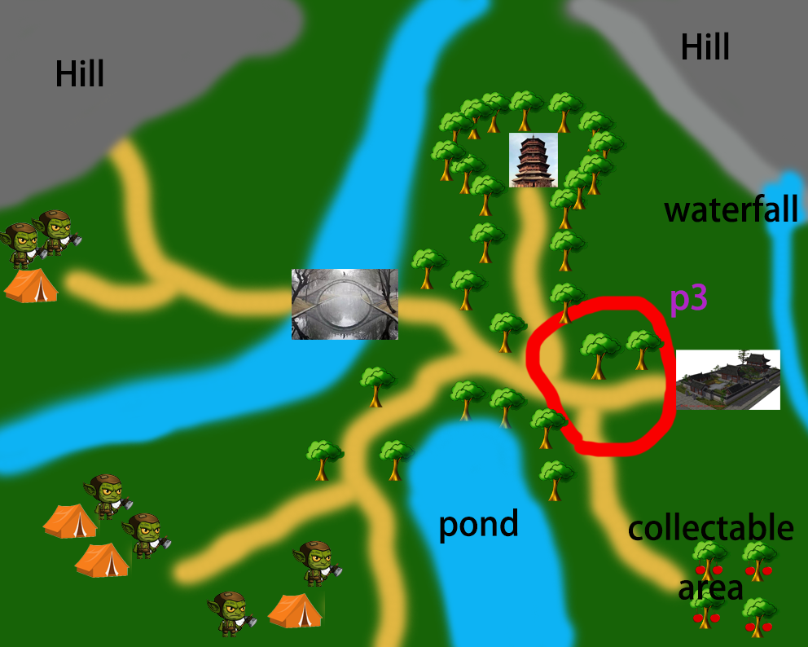

**Cutscene 3**

A few moments later, Tommy and Jervis heard the roaring nearby.

They were aware that it’s the goblins.

They prepared to fight.

The Goblin commander orders goblin soldiers to move forward and fight with jervis and the hunter. **(Set Camera to show the goblins are moving forward)**

Tommy told jervis to stay back and he went forward to deal with most of the goblins.(Player will control the hunter to have a small battle). **(Set Camera to follow with Tommy)**

**Battle Start**

**After battle finished**

**Cutscene 4**

jervis wasn't aware that one goblin soldier was getting close quietly and sneak attacked jervis suddenly. **(Set camera to focus on jervis and that goblin)**

Jervis doesn’t have any time to respond to that attack.

At that moment, the hunter appeared in front of jervis and got the fatal attack instead of Jervis. The goblin’s sword passes through the hunter's body.

The same past memory appeared in jervis’ memory.

It was Jervis’ parents who sacrificed their lives to protect jervis 3 years ago.

**Flashback Cutscene 3(a few seconds)**

Showed the animation that jervis’ parents protect jervis from the goblin’s attack.

Jervis was shocked at that moment.

The hunter said “Don’t stop, run fast and survive as long as you can.”

The Hunter used his last strength to hit back goblins.

Then he lied under the tree and lost consciousness.

Jervis was sorrowful and angry, she took hunter’s sword, motivated to fight goblins.**(Set camera to follow with Jervis)**

**Boss Battle Start (a few goblin soldiers and a boss goblin)**

She killed all goblins soldiers, then the goblin commander moved forward, the next was the boss battle.

**Boss Battle End**

**Ending**

She finally killed the goblin commander. She dug a hole and buried the hunter’s body**(if possible, show Jervis is crying when she is burying Tommy)**.

**Game End**